**Name: Vinodhini S**

**Phone:**

8925300474

1. **Mail:**

vinosodaiyah@gmail.com

**Linkedin:**

https://www.linkedin.com/in/vinodhini-s-b8211b1b2/

# Skill Highlights

* Google Analytic
* Keyword Research
* Facebook Ads
* Linkedin Ads
* Instagram Ads
* Email Marketing
* Content Management

# Languages

English

Tamil

Hindi

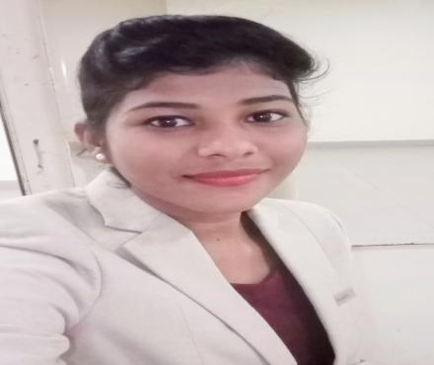

# Experience

**01/2019 -02/2020**

**Marketing Executive - Casa Grand Builders, Chennai**

* Enquiring customers needs based on their budget and availability
* Generating prospect leads through reference.
* Uploading posts in Facebook and Instagram.
* Analyzing customers source and concentrating more on it like newspaper or website.
* Campaigning in particular location where customers come from by doing analytic research.
* Doing competitive research and submitting the report to HOD

# Education

**2015-2018**

**Bachelor of Science: Hotel Management and Catering Science at**

**Bharathiar University**

# Certifications

**Digital Marketing Certificate - Besant Technologies**

SEO,SMM,SMO,Email Marketing, Content Writing, Affiliate Marketing, Image editing etc

# References

Mr.Manimaran (digital marketing trainer): 7708039329

# Summary

Creative Digital Marketing Executive with well experienced real estate marketing knowledge.

Possessing excellent management skills and having the ability to work with the minimum of supervision with best practices.